Here are the screenshots of the medical store that I make

**Features**

* Medicine is inserted
* Medicine is purchased
* Sales records of all the medicine
* Monthly report is generated with the loss or profit
* You can also check not only the monthly report but you can also generate the report for your custom days like you want to check 3- or 8-days report then you can make report
* Login is for the purpose of safety and security
* Logout is for the reliability of the application
* We also use code refactoring that make code cleaner and this feature is like the heart of all the other features
* Search feature is also present in this application for the sake of reliability this will help you to find the medicine if medicine is present then it shows the medicine otherwise you will be informed that medicine is not present in his store
* Main thing is that this application is 100% custom
* Not a single line is copied from the internet

**1 Login Form**

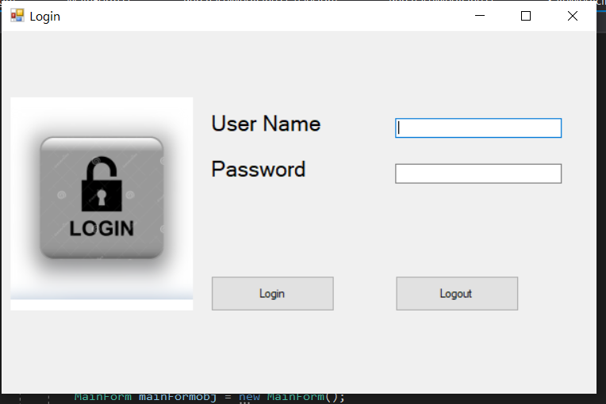

**2 Main Page or Home Page**

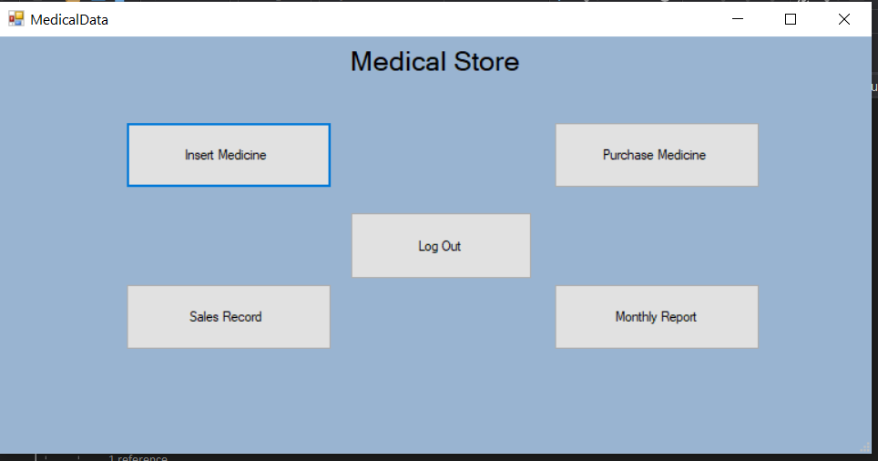

**3 Insert Medicine**

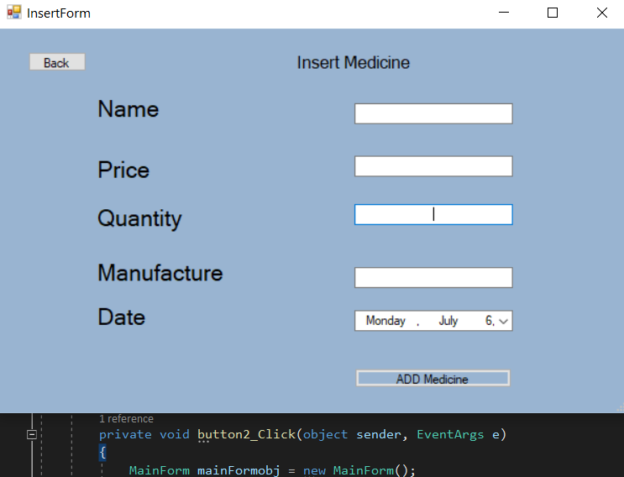

**4 When medicine is inserted**

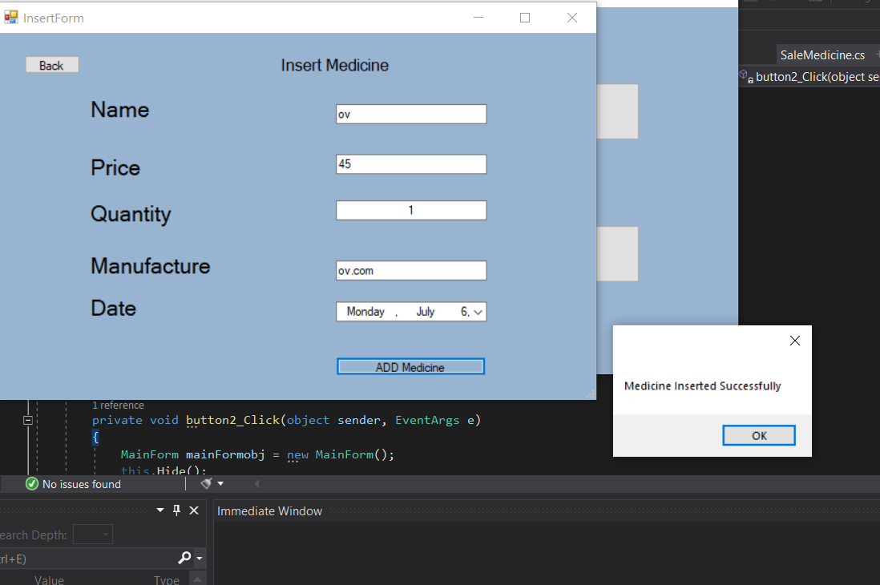

**5 Purchase Medicine**

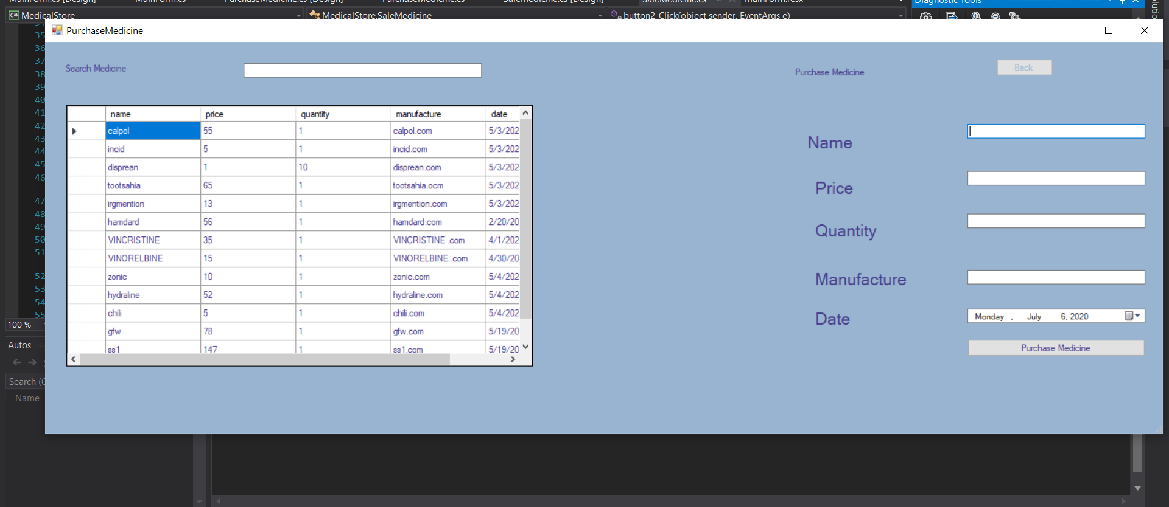

**6 When medicine is sold**

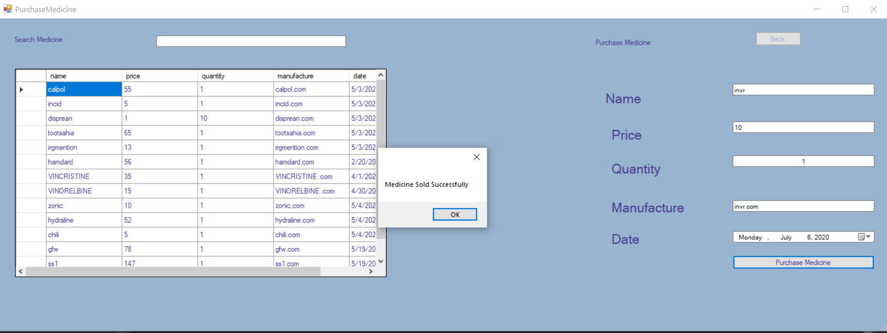

**7 Sale Records**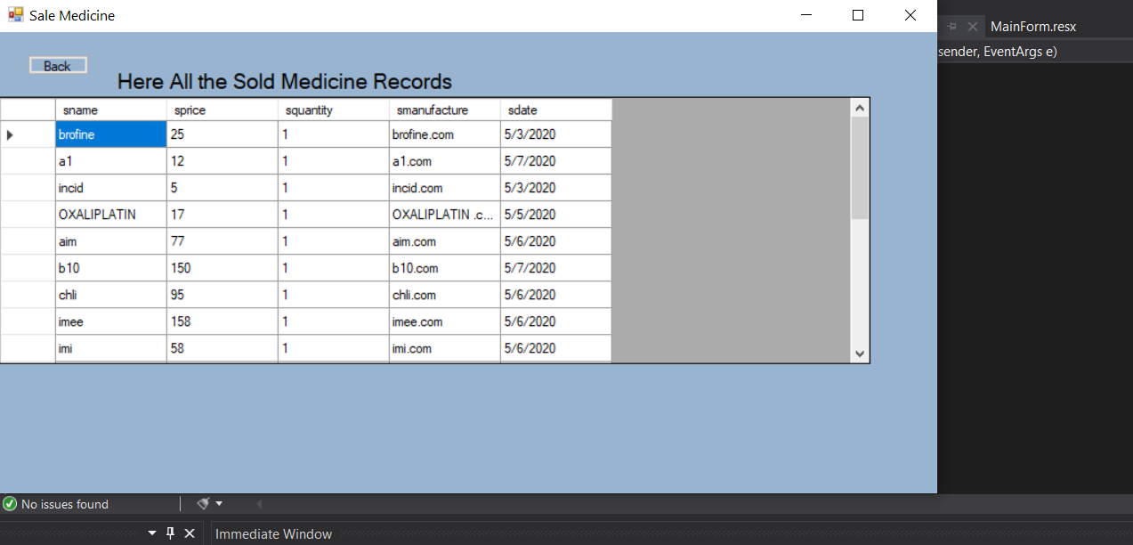

**8 Monthly Report**

